 | RA 029B Contingency Plan v1 August 2021 | RISK ASSESSMENT  RECORDING FORM

Location or School  Address: St. Matthew’s Primary School | Date assessment  Undertaken 31.08.2021 | Assessment undertaken.  by: Jeanne Fairbrother  Stephen Murphy
Activity or  situation Contingency Plan | Review  date: Weekly review or as appropriate for the activity | Signature: Signature

Background information

Contingency Plan School opening COVID 19. Aug 2021

The DfE guidance explains the actions school leaders should take to reduce the risk of transmission of coronavirus (COVID-19) in their school. It includes advice from Department of Health and Social Care (DHSC) and Public Health England (PHE).

DfE guidance, states that schools should have an ‘outbreak management plan’, this is the same as the contingency plan outlining how they would operate if any of the measures described in the document below were recommended for their setting or area. This includes how they would ensure every child, pupil or student receives the quantity and quality of education and care to which they are normally entitled.

See Guidance :Contingency framework: education and childcare settings

This risk assessment applies to:
- primary schools
- secondary schools (including sixth forms)
- special schools, special post-16 providers and alternative provision
- 16 to 19 academies
- infant, junior, middle, upper schools

Please note that this risk assessment has been created in line with the current government guidance. It contains sample control measures that fit with the system of controls contained in Government guidance. One size does not fit all, and schools should make this model risk assessment their own and reflect any local guidance.

Control measures in purple indicate different measures are in place for different settings. Please choose the setting that applies and delete the others to make this reflect your school/setting:
- All settings
- Early years
- Primary schools
- Secondary Schools & post 16 settings
- Special schools
- Wraparound and out of school providers

Please see [NEW] & [UPDATED] sections

Legislation and guidance
Health and Safety at Work Act etc. 1974
Management of H&S at Work Regulations 1999
Workplace (Health, Safety and Welfare) Regulations 1992
DfE Actions for schools plus associated COVID 19 Guidance
Public Health England Guidance

1) Hazard / Activity | 2) Who can be harmed and how? | 3) What controls exist to reduce the risk?  Have you followed the hierarchy of controls (eliminate, substitute etc)? | Risk Score  Consequence  X Likelihood | 4) Any further action.  This should be included in the action plan (5), below
Collaboration with local authorities during localised outbreak of COVID 19 cases | Staff, pupils, visitors, contractors increased risk of transmission of COVID 19 | - Local authorities, directors of public health (DsPH) and PHE health protection teams (HPTs) are responsible for managing localised outbreaks.  - School liaises and responds to guidance from DPH& local PH Teams | 3X2=6  Review this score as the more measures in place will reduce it.  Each score is for this line only do not add together | If you identify any actions to complete, transfer them to the action plan below (5)
Failure to assess the risks of COVID 19 transmission in school.  All settings unless indicated | Staff, pupils, visitors, contractors increased risk of transmission of COVID 19 | - School has assessed the reasonably foreseeable risks of transmission of COVID 19. See RA 029A School opening COVID 19 v2 Aug 2021  - The risk assessment is regularly reviewed as circumstances in school and the public health advice changes.  - School monitors whether the controls in place are effective and working as intended. | 3X2=6  Review this score as the more measures in place will reduce it.  Each score is for this line only do not add together | If you identify any actions to complete, transfer them to the action plan below (5)
Failing to have adequate outbreak management plans to allow for stepping measures up and down.  All settings unless indicated | Staff, pupils, visitors, contractors increased risk of transmission of COVID 19 | - School has RA 029A School opening COVID 19 v2 Aug 2021  risk assessment for following the new guidance, and this contingency plan risk assessment for stepping up or stepping down measures if required to by Public Health.  - School has outbreak management plans outlining how we would operate if there were an outbreak in school or local area.  - School will call the DfE helpline on 0800 046 8687 selecting option 1 for advice on the action to take in response to a positive case who will escalate the issue to the local health protection team where necessary and advise if any additional action is required, such as implementing elements of the outbreak management plan.  - School will consult local Public Health Teams to contain any outbreak by following local health protection team advice below:  - 0161 217 6012  Early Years  - Setting will notify Ofsted of any confirmed cases staff or child within 14 days through the usual notification channels.  - Setting will make Ofsted aware if the setting is advised to close as a result. | 3X2=6  Review this score as the more measures in place will reduce it. | If you identify any actions to complete, transfer them to the action plan below (5)
[NEW] Communication  All settings unless indicated | Staff, pupils, visitors, contractors increased risk of transmission of COVID 19 | - School will communicate its plan for addressing any imposed restrictions with parents:  - Opening arrangements.  - Access for specific targeted groups where applicable, such as certain year groups, vulnerable pupils and children of critical workers.  - Any reviews of the school’s protective measures as part of school’s risk assessments.  - The arrangements for remote working.  - School will keep all relevant parties up to date with the circumstances of any imposed restrictions and how these affect the school as the situation develops. | 3X2=6  Review this score as the more measures in place will reduce it. | If you identify any actions to complete, transfer them to the action plan below (5)
[NEW] Return to school  Early years settings, primary schools, Secondary schools, and post-16 settings | Staff, pupils, visitors, contractors increased risk of transmission of COVID 19 | Early years settings, primary schools, Secondary schools, and post-16 settings  - School recognises that testing is voluntary.  - Where advised to do so by a Director of Public Health and/or the local HPT, the school will encourage staff to undertake LFD tests at home prior to their return to school and/or for a period following their return.  - The headteacher will inform staff, pupils, and parents, prior to the return to school, whether any further restrictions, such as the use of bubbles and face coverings, have been resumed. | 3X2=6  Review this score as the more measures in place will reduce it | If you identify any actions to complete, transfer them to the action plan below (5)
[UPDATED] Face coverings | Staff, pupils, visitors, contractors increased risk of transmission of COVID 19 | Early years settings and primary schools  - Face coverings may be reintroduced in communal areas and classrooms for members of staff.  - School/setting may be required to reintroduce the use of bubbles in order to resume social distancing and limit the transmission of coronavirus.  - School/setting will adhere to any conditions set out by the local HPT. | 3X2=6  Review this score as the more measures in place will reduce it | If you identify any actions to complete, transfer them to the action plan below (5)
Re-introduce Shielding - CEV staff & pupils, pregnant staff  All settings unless indicated | Staff, pupils, visitors, contractors increased risk of transmission of COVID 19 | - Shielding is currently paused and will only be reintroduced by national government in the event of a major outbreak that poses a significant risk to individuals on the shielded patient list (SPL),  - Settings outbreak management plan covers this possibility.  - All identified CEV & pregnant staff have individual risk assessments detailing the measures the setting has put in place to reduce risks to these staff, including how these protective measures have been reviewed as part of an updated workplace risk assessment.  - Shielding will be re-introduced on advice from DfE/ Public Health teams. All staff will be required to inform the Headteacher if they are CEV. CEV & pregnant staff will be given duties that enable them to work from home. | 3X2=6  Review this score as the more measures in place will reduce it | If you identify any actions to complete, transfer them to the action plan below (5)
[NEW] Transport  All settings unless indicated | Staff, pupils, visitors, contractors increased risk of transmission of COVID 19 | In the event of having to increase measures:  - school will encourage staff & pupils to walk or cycle wherever possible and to avoid public transport.  - If needing to use public transport, they are required to wear a face covering while travelling, unless exempt.  - If directed, pupils and staff may also need to resume mandatory wearing of face coverings on dedicated school transport unless they are exempt.  - Transport services to and from the school will continue to operate as normal during times of local restriction where pupils are still attending.  - If transport cannot operate as normal, school will consider alternative options and communicate these to all parents and pupils in advance. | 3X2=6  Review this score as the more measures in place will reduce it | If you identify any actions to complete, transfer them to the action plan below (5)
Residential educational visits  All settings unless indicated | Staff, pupils, visitors, contractors increased risk of transmission of COVID 19 | - All visits are risk assessed and include current local restrictions.  - School will consider carefully if the educational visit is still appropriate and safe.  - Only pupils who are attending the setting will go on an educational visit. | 3X2=6  Review this score as the more measures in place will reduce it | If you identify any actions to complete, transfer them to the action plan below (5)
[UPDATED] School failing to plan:  - Open days  - Transition & taster days  - Parental attendance  - Performances  All settings unless indicated | Staff, pupils, visitors, contractors increased risk of transmission of COVID 19 | - All such events are risk assessed and include current local restrictions.  - School will consider carefully if the event is still appropriate and safe.  - If local incidence of Coronavirus increases significantly, under guidance from Stockport Public Health team, school will:  - Move all parent and professional meetings online.  - Restrict attendance to performances or move them online.  - Ensure that where events cannot be moved online, they are held in well-ventilated spaces with adequate space for social distancing. | 3X2=6  Review this score as the more measures in place will reduce it | If you identify any actions to complete, transfer them to the action plan below (5)
[UPDATED] Attendance restrictions - increased Covid infections | Staff, pupils, visitors, contractors increased risk of transmission of COVID 19 | Early years settings  If advised the need for attendance restrictions by the DfE, vulnerable children and children of critical workers should be allowed to attend.  If attendance is limited, remote learning will be delivered to children who remain at home.  Early years settings as part of a primary school  - School-based nurseries in primary schools will have the discretion to follow the arrangements set for the primary school  Primary school  - If some attendance restrictions are needed, all vulnerable children, children of critical workers, children in reception, year 1 and year 2 should still be allowed to attend.  - If, by exception, attendance is restricted further, vulnerable children and children of critical workers should still be followed to attend.  Out-of-school settings and wraparound childcare  - If attendance restrictions are needed, vulnerable children and young people should be allowed to attend.  - For all other children, parents and carers should only be allowed to access these providers for face-to-face provision for their children for a limited set of essential purposes, such as to allow them to go to or seek work, attend a medical appointment or undertake education and training.  - Restrictions may vary depending on whether provision will be operating during school term-time and/or school holidays.  Summer schools (delivered under DfE’s summer school funding scheme)  - In most circumstances, children should be allowed to attend summer schools as planned.  - Facilities and activities will reflect any local or national restrictions.  - If attendance restrictions are needed as a last resort, the academic element of the programme may need to be delivered remotely | 3X2=6  Review this score as the more measures in place will reduce it | If you identify any actions to complete, transfer them to the action plan below (5)
[NEW] Food provision  All settings unless indicated | Staff, pupils, visitors, contractors increased risk of transmission of COVID 19 | - School will provide meal options for all pupils who are attending.  - FSM or food parcels to eligible pupils who are not attending school, where they:  - are self-isolating.  - have had symptoms or have tested positive.  - are not attending due to the implementation of local restrictions advised by local PHE teams. | 3X2=6  Review this score as the more measures in place will reduce it | If you identify any actions to complete, transfer them to the action plan below (5)
[NEW] Safeguarding  All settings unless indicated | Staff, pupils, visitors, contractors increased risk of transmission of COVID 19 | School will ensure safeguarding arrangements remain effective during periods of restricted attendance.  - A DSL or Deputy will always be on-site to ensure adequate safeguarding oversight.  - Parents will be informed who the staff responsible for safeguarding are in school.  - Safeguarding team will coordinate regular check-ins with all parents of pupils in school, with a particular focus on those that are not attending live sessions and returning work.  - The safeguarding team will stay in regular, direct contact with all families on the vulnerable register. | 3X2=6  Review this score as the more measures in place will reduce it | If you identify any actions to complete, transfer them to the action plan below (5)
[NEW] Teaching & learning  All settings unless indicated | Staff, pupils, visitors, contractors increased risk of transmission of COVID 19 | If restrictions to on-site education are required, the school will offer immediate access to high-quality remote education for all pupils who are required to remain at home:  - Live sessions on Google Meet  - Video sessions and work posted on Class Dojo  - Pupils return work on Class Dojo portfolios  - Staff to provide regular feedback on learning  - Weekly attendance registers to be compiled by class teachers and shared with SLT. | 3X2=6  Review this score as the more measures in place will reduce it | If you identify any actions to complete, transfer them to the action plan below (5)

Risk Rating | Action Required
20 - 25 | Unacceptable – stop activity and make immediate improvements
10 - 16 | Urgent action – take immediate action and stop activity, if necessary, maintain existing controls vigorously
5 - 9 | Action – Improve within specific timescales
3 - 4 | Monitor – but look to improve at review or if there is a significant change
1 - 2 | Acceptable – no further action but ensure controls are maintained & reviewed

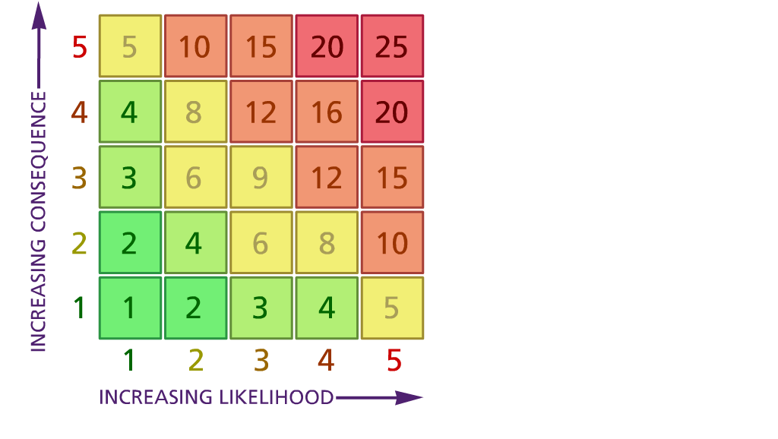

Likelihood: Consequence
(1) List hazards something with the potential to cause harm here
(2) List groups of people who are especially at risk from the significant hazards which you have identified
- List existing controls here or note where the information may be found. Then try to quantify the level of risk the likelihood of harm arising that remains when the existing controls are in place based on the number of persons affected, how often they are exposed to the hazard and the severity of any consequence. Use this column to list the controls that you might take and develop all or some of that list into a workable action plan. Have regard for the level of risk, the cost of any action and the benefit you expect to gain. Agree the action plan with your team leader and make a note of it overleaf. If it is agreed that no further action is to be taken this too should be noted.

5 – Very likely 5 – Catastrophic

4 – Likely 4 – Major
3 – Fairly likely 3 – Moderate

2 – Unlikely 2 – Minor

1 – Very unlikely 1 – Insignificant

 | 5. Action plan | Responsible | Completed
1
2
3
4
5
6
7
8
9
10
 | Action plan agreed by (NAME & DATE)

