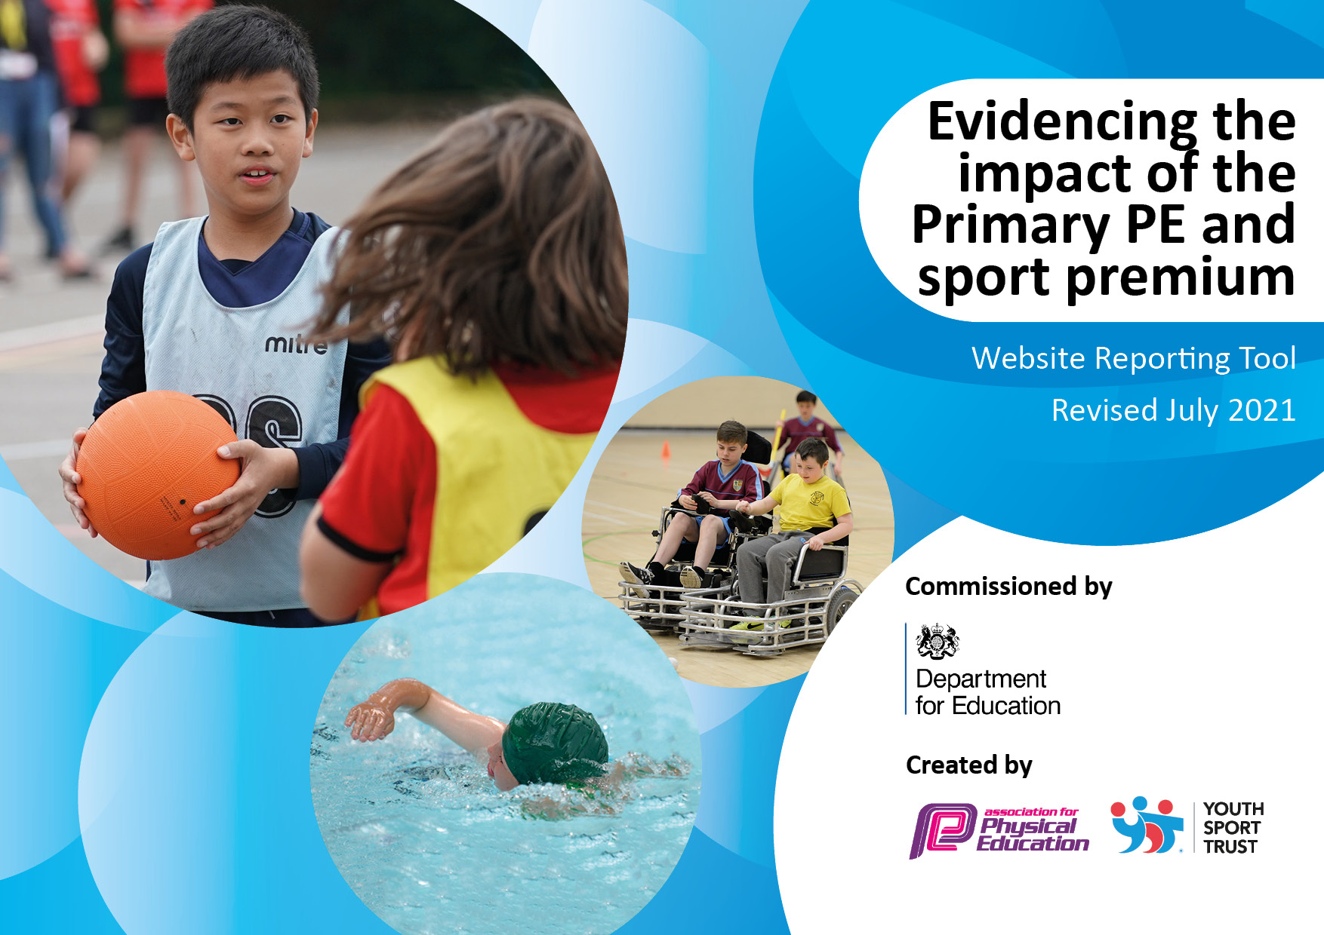
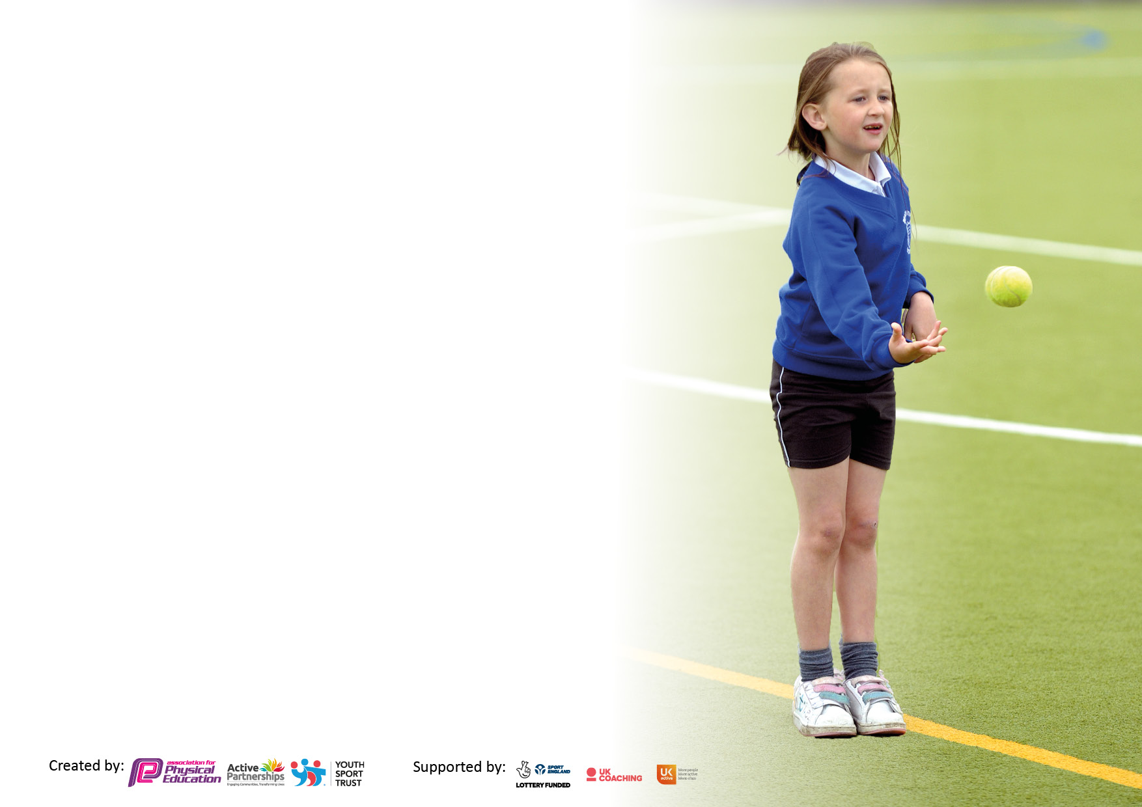

It is important that your grant is used effectively and based on school need. The Education Inspection Framework makes clear there will be a focus on ‘whether leaders and those responsible for governors all understand their respective roles and perform these in a way that enhances the effectiveness of the school’.

Under the Quality of Education Ofsted inspectors consider:
Intent - Curriculum design, coverage and appropriateness
Implementation - Curriculum delivery, Teaching (pedagogy) and Assessment
Impact - Attainment and progress

To assist schools with common transferable language this template has been developed to utilise the same three headings which should make your plans easily transferable between working documents.

Schools must use the funding to make additional and sustainable improvements to the quality of Physical Education, School Sport and Physical Activity (PESSPA) they offer. This means that you should use the Primary PE and sport premium to:

- Develop or add to the PESSPA activities that your school already offer
- Build capacity and capability within the school to ensure that improvements made now will benefit pupils joining the school in future years
- The Primary PE and sport premium should not be used to fund capital spend projects; the school’s budget should fund these.

Pleasevisitgov.ukfortherevisedDfEguidanceincludingthe5keyindicatorsacrosswhichschoolsshoulddemonstrate animprovement.Thisdocumentwillhelpyoutoreviewyourprovisionandtoreportyourspend.DfEencouragesschools to use this template as an effective way of meeting the reporting requirements of the Primary PE and sport premium.

We recommend you start by reflecting on the impact of current provision and reviewing the previous spend.

Schools are required to publish details of how they spend this funding, including any under-spend from 2019/2020, as well as on the impact it has on pupils’ PE and sport participation and attainment. All funding must be spent by 31st July 2022.

We recommend regularly updating the table and publishing it on your website throughout the year. This evidences your ongoing self-evaluation of how you are using the funding to secure maximum, sustainable impact. Final copy must be posted on your website by the end of the academic year and no later than the 31st July 2021. To see an example of how to complete the table please click HERE.
Created by: Supported by:

Details with regard to funding
Please complete the table below.

Total amount allocated for 2020/21 | £17550
How much (if any) do you intend to carry over from this total fund into 2021/22? | £1,412
Total amount allocated for 2021/22 | £17550
Total amount of funding for 2021/22. To be spent and reported on by 31st July 2022. | £18,962
Swimming Data
Please report on your Swimming Data below.

Meeting national curriculum requirements for swimming and water safety.

N.B. Complete this section to your best ability. For example you might have practised safe self-rescue techniques on dry land which you can then transfer to the pool when school swimming restarts.
Due to exceptional circumstances priority should be given to ensuring that pupils can perform safe self rescue even if they do not fully meet the first two requirements of the NC programme of study
What percentage of your current Year 6 cohort swim competently, confidently and proficiently over a distance of at least 25 metres?  N.B. Even though your pupils may swim in another year please report on their attainment on leaving primary school at the end of the summer term 2021.  Please see note above | 65%
What percentage of your current Year 6 cohort use a range of strokes effectively [for example, front crawl, backstroke and breaststroke]?  Please see note above | 13%
What percentage of your current Year 6 cohort perform safe self-rescue in different water-based situations? | 65%
Schools can choose to use the Primary PE and sport premium to provide additional provision for swimming but this must be for activity over and above the national curriculum requirements. Have you used it in this way? | No

Action Plan and Budget Tracking
Capture your intended annual spend against the 5 key indicators. Clarify the success criteria and evidence of impact that you intend to measure to evaluate for pupils today and for the future.

Academic Year: 2020/21 | Total fund allocated: | Date Updated:
Key indicator 1: The engagement of all pupils in regular physical activity – Chief Medical Officers guidelines recommend that primary school pupils undertake at least 30 minutes of physical activity a day in school |  |  |  | Percentage of total allocation:
 |  |  |  | 10%
Intent | Implementation |  | Impact
Your school focus should be clear what you want the pupils to know and be able to do and about  what they need to learn and to  consolidate through practice: | Make sure your actions to achieve are linked to your intentions: | Funding allocated: | Evidence of impact: what do pupils now know and what can they now do? What has changed?: | Sustainability and suggested next steps:
Launch “A mile a day”  Increase Active Lunchtime Opportunities – playground games/activities with playground leaders.  Maintain curriculum at 2 hours physical activity per week | Aim for classes to do at least 2 sessions of ‘a mile a day’ per week  New outdoor active climbing station. (Oct 21)  Review current PE timetable ensuring all pupils have a 2 hour offer of curriculum PE. | £1910 – mile track and sports trail in playground  New outdoor active climbing station. (Oct 21) | Increased daily activity from all classes.  Children are more active at lunchtimes/playtimes. | Maintain ‘a mile a day’ scheme into next academic year.  Train more leaders & lunchtime staff to deliver active playgrounds.  Ensure 2 hour offer stays in place.
Key indicator 2: The profile of PESSPA being raised across the school as a tool for whole school improvement |  |  |  | Percentage of total allocation:
 |  |  |  | 0%
Intent | Implementation |  | Impact
Your school focus should be clear what you want the pupils to know and be able to do and about  what they need to learn and to  consolidate through practice: | Make sure your actions to achieve are linked to your intentions: | Funding allocated: | Evidence of impact: what do pupils now know and what can they now do? What has changed?: | Sustainability and suggested next steps:
Improving Behaviour & Attitudes to Learning  Raise the profile of PESS across the school  Heightening awareness of Health & Well Being/SMSC | Use ‘A mile a day’ to break from classroom when children become restless.  ‘Spirit of the games values’ to mirror school values and ethos - certificates presented in whole school ‘Shine’ assemblies  Celebrating success through newsletters, website & ClassDojo |  | Pupils understand the contribution of PA, SS & sport to their overall development.  Pupils to become more aware and responsible for the importance of being physically active  Higher % take up of extra-curricular offer | Maintain ‘a mile a day’ scheme next academic year and use in classroom practise in the same way.

Key indicator 3: Increased confidence, knowledge and skills of all staff in teaching PE and sport |  |  |  | Percentage of total allocation:
 |  |  |  | 88%
Intent | Implementation |  | Impact
Your school focus should be clear | Make sure your actions to | Funding | Evidence of impact: what do | Sustainability and suggested
what you want the pupils to know | achieve are linked to your | allocated: | pupils now know and what | next steps:
and be able to do and about | intentions: |  | can they now do? What has
what they need to learn and to |  |  | changed?:
consolidate through practice:
Raise the quality of teaching across the school  High Quality of PE equipment to support high quality delivery  Signpost CPD events for teaching staff.  Introduce an assessment programme for PE to monitor progress | Buy in to SSP programme to gain unlimited access to competition programme.  Specialist sports coach to develop and deliver a broad and engaging curriculum for all.  Stock check of current equipment  See SSP list of essential PE equipment & order accordingly.  Contact CDAT lead teacher to enquire about PE training opportunities.  Implement simple R/Y/G tool for tracking of PE skills/progress/attainment. | £1,100  £13,500  £2052 | Higher quality teaching & learning  Improved teacher planning by knowledge of children’s current levels | Ensure an annual stock take to maintain the high quality of equipment
Key indicator 4: Broader experience of a range of sports and activities offered to all pupils |  |  |  | Percentage of total allocation:
 |  |  |  | 0%
Intent | Implementation |  | Impact
Your school focus should be clear | Make sure your actions to | Funding | Evidence of impact: what do | Sustainability and suggested
what you want the pupils to know | achieve are linked to your | allocated: | pupils now know and what | next steps:
and be able to do and about | intentions: |  | can they now do? What has
what they need to learn and to |  |  | changed?:
consolidate through practice:
Broaden Curriculum Offer  Broaden extra-curricular offer | Review current curriculum map.  Ensure there is an even balance between in and outdoor activities as well as a broad range overall.  Review current extra-curricular activity offer - Develop offer to ensure each year group & gender are catered for e.g. clubs, festivals, health & activity weeks, school challenge, family challenge, Be Inspired Challenges, School Games |  | Greater commitment to participation in PE lessons | Review current curriculum map using GetSet4PE  Target Inactive pupils

Key indicator 5: Increased participation in competitive sport |  |  |  | Percentage of total allocation:
 |  |  |  | 2%
Intent | Implementation |  | Impact
Your school focus should be clear | Make sure your actions to | Funding | Evidence of impact: what do | Sustainability and suggested
what you want the pupils to know | achieve are linked to your | allocated: | pupils now know and what | next steps:
and be able to do and about | intentions: |  | can they now do? What has
what they need to learn and to |  |  | changed?:
consolidate through practice:
Increase attendance (compared to last year) at local sports competitions (Stockport SHAPES alliance).  Increase participation from SEN/lower ability children.  Promote positive behaviour linked with SSSPs “Spirit of the Game Awards”. | Sign up to 2 events per term (minimum) Stockport SHAPES alliance  Increased attendance to ‘Be Inspired’ events  PE display board: Spirit of the Games Awards | £400 transport costs | Winners of the ‘Stockport Be Inpsired Award’ from Stockport SHAPES Alliance – Commitment to Inclusion 2021/22  Increased participation at competitive events. | Continue to attend ‘Be Inspired’ events.  Begin to attend ‘Excel’ (top 10% sporting achievers) events.  Increase Level 1 competitive provision - Level 1 competitions delivered at the end of each unit

Signed off by
Head Teacher: | Stephen Murphy
Date: | 26/07/2022
Subject Leader: | Beth Beecher
Date: | 26/07/2022
Governor: | Helen Wetherall
Date:

